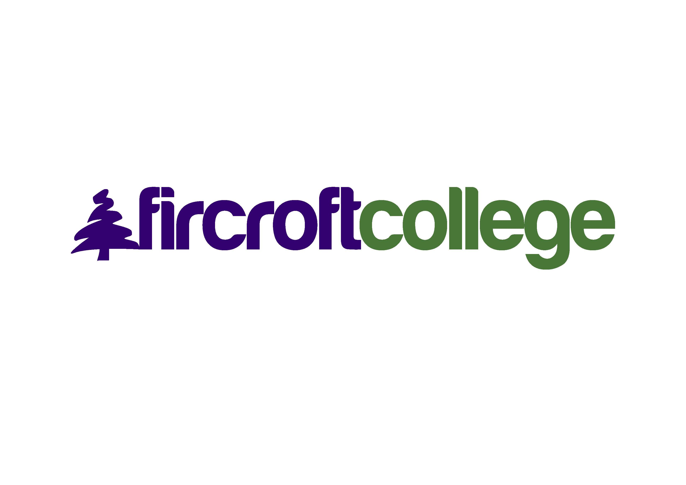

**Alex Pettifer MBE**

Alex has had a highly successful career in Estates and Facilities leadership roles as well as serving for a number of years as Chairman for several charitable Trusts.

Alex’s career includes:

Director of Estates and Facilities, Sheffield Hallam University 1982 – 2010

Trustee, Sheffield Hallam University Charitable Trust 2011 – present

Deputy Chairman, Sheffield City Trust – 1996 – present

Former Chairman, Sheffield Industrial Museums Trust 1995 – 2021

Former Chairman of St Luke’s Hospice 2004 – 2017

Alex was awarded an Honorary Doctorate from Sheffield Hallam University in 2011

Alex was awarded an MBE in the Queen’s Birthday Honours List in June 2010 for his “Contribution to Higher Education and the Community of Sheffield”.

**Steve Lewis**

After Fircroft, in 1974, Steve went on to train as a teacher in Bromsgrove before moving to Essex to take up his first teaching post at a Secondary school, teaching history and maths. Two years later Steve returned to the Midlands and into Primary Education. He was responsible for maths education in both schools he worked at.

Whilst at the second of his two schools, Steve gained a Masters in Education, followed by a Post - graduate Diploma in Maths Education. Steve achieved the position of Deputy Headteacher and was responsible for introducing Safeguarding and Child Protection, which at the time was surprisingly unusual in schools. Also, Steve ran the school’s football teams for many years and achieved a great deal of success at county and national level. Perhaps his experience of being leading goal scorer in the Fircroft football team played a part after all?

In 2005, Steve became a headteacher in a school in North Wales for 6 years. This was an immense responsibility and gave him the opportunity to truly lead on the issues close to his heart, which was trying to meet the individual needs of all those associated with the school – children, staff and even parents! This was deeply rooted in his own experiences of school life as a pupil and the immense example provided by Fircroft College staff.

In 2012 Steve set up Sponsor A Gambian Teacher (SAGT), a charity that provides sponsorship for teachers in village schools to attend The Gambia College, a department of Gambia’s only university. Working with headteachers in The Gambia, West Africa, SAGT has assisted over 100 teachers to become qualified and is currently sponsoring 24 teachers in their training.

Steve is now Chair of Denbighshire County of Sanctuary attempting to address the needs of refugees in Wales. In his spare time he sings in 2 choirs and is learning Welsh. Never stop learning!

Diolch yn fawr .. Thank you very much!